**Database Development and Class Registration**

Austin Blair

The University of Arizona Global Campus

CST499: Capstone for Computer Software Technology

Joseph Rangitsch

2-24-2025

**MySQL Database** 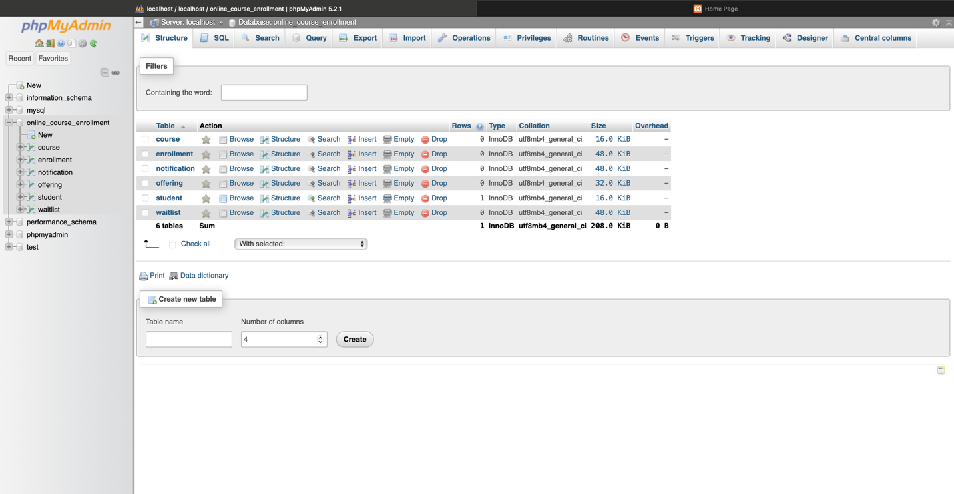

**MySQL Tables**

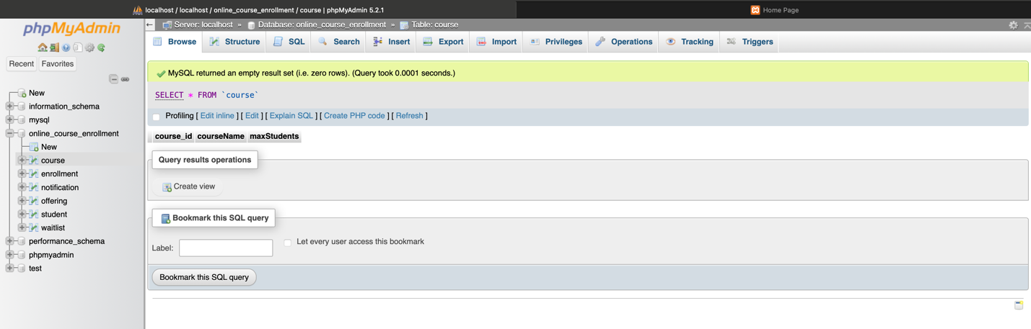

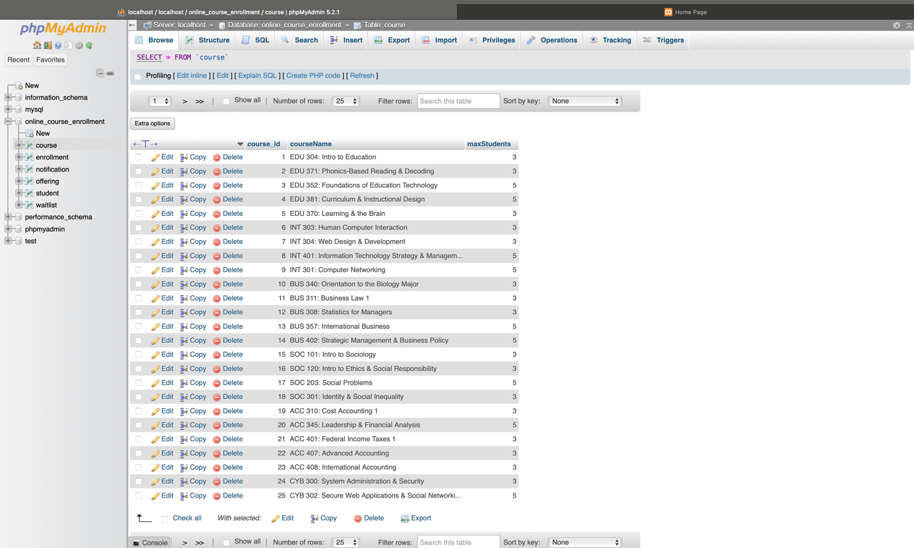

Course Table Before & After

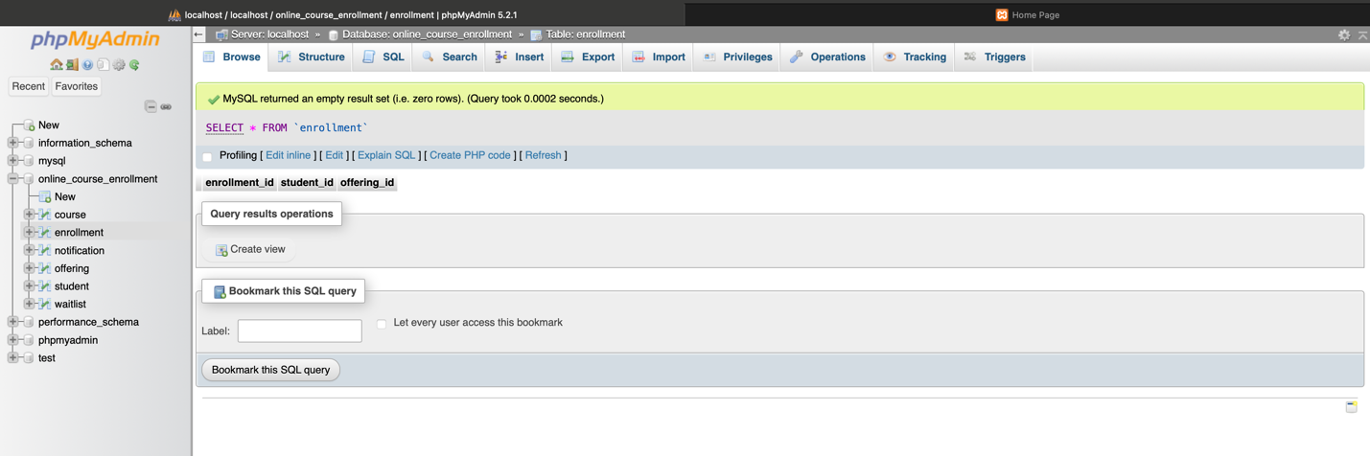

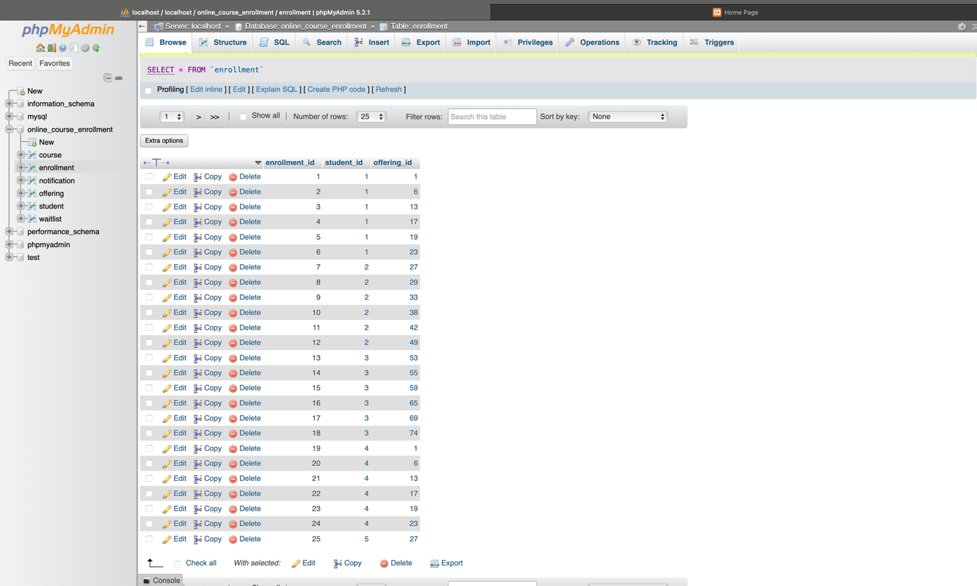

Enrollment Table Before & After

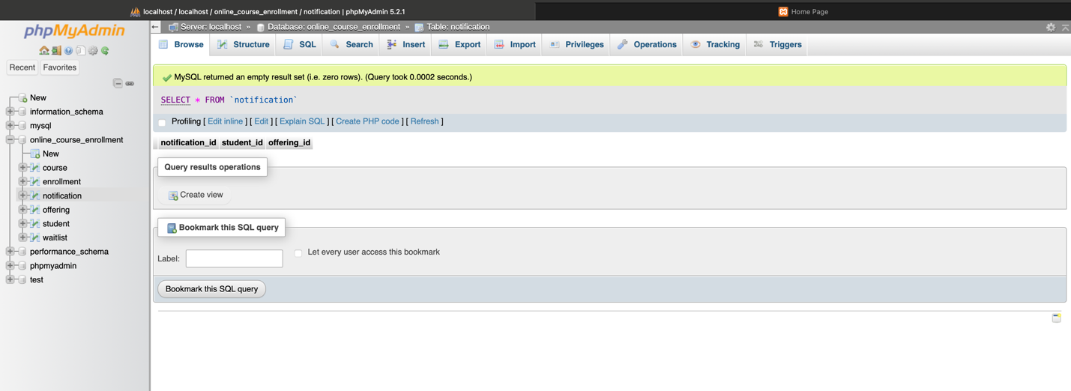

Notification Table

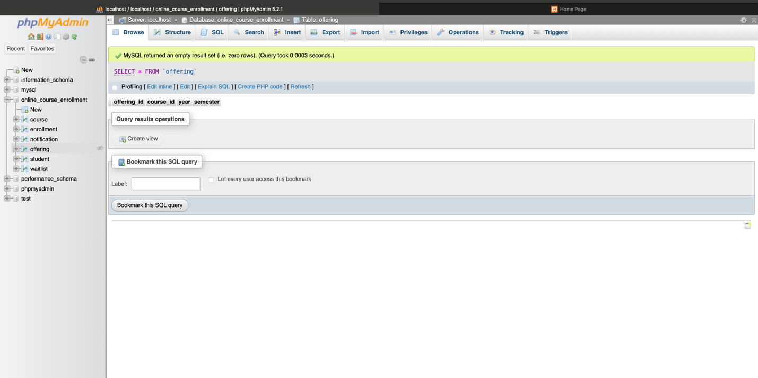

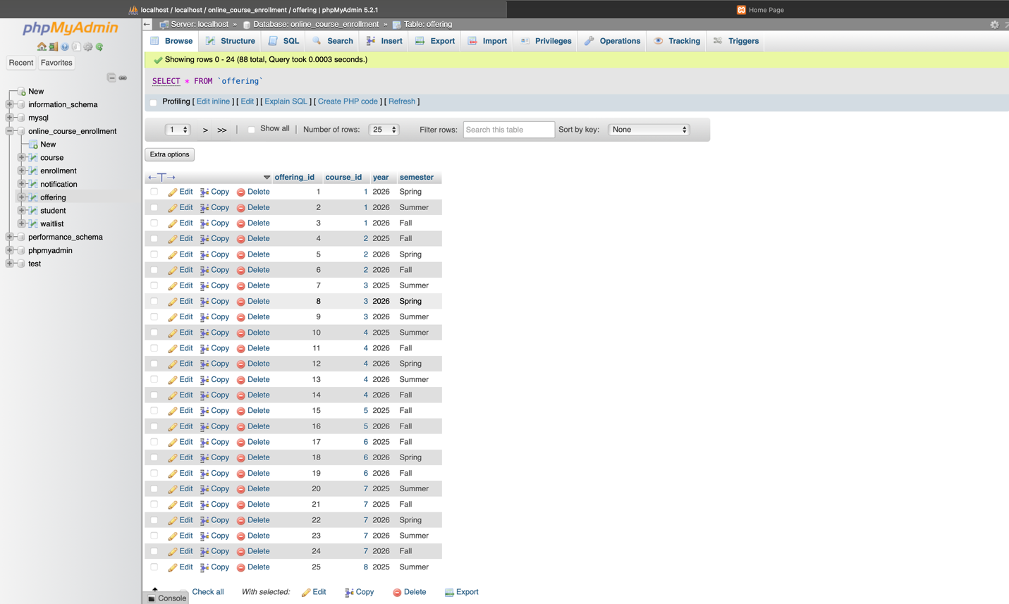

Offering Table Before & After

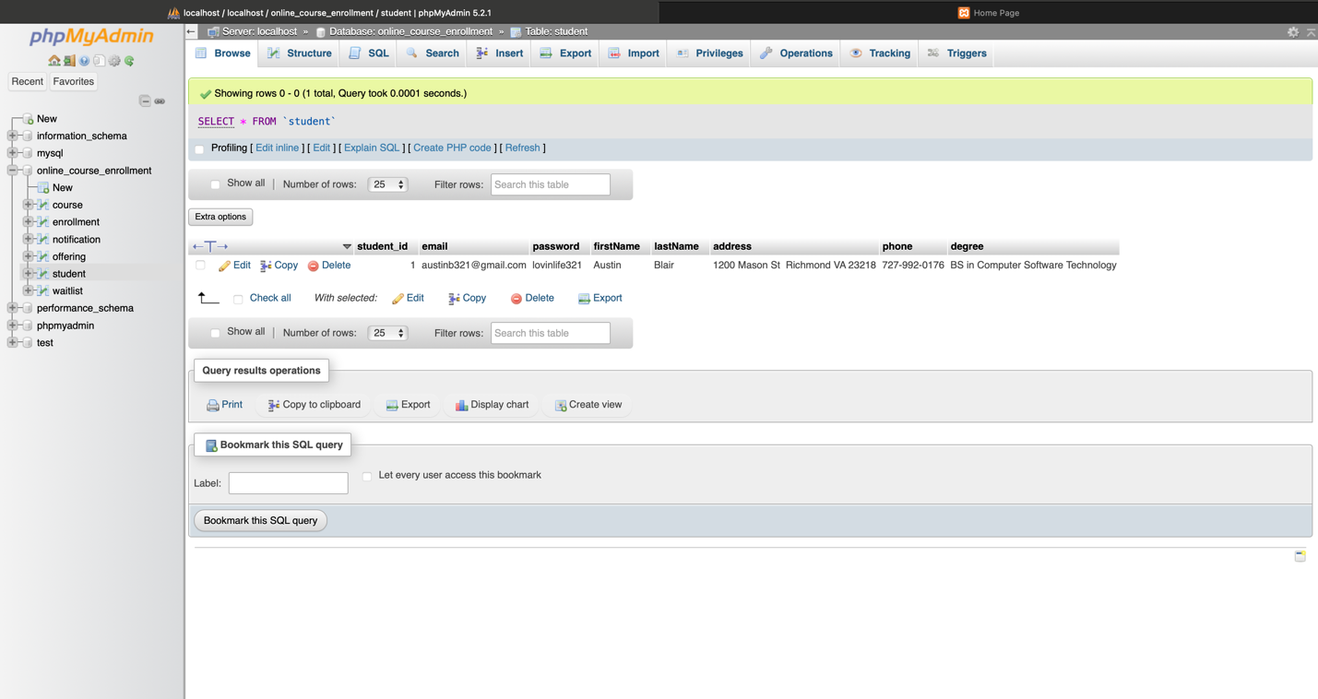

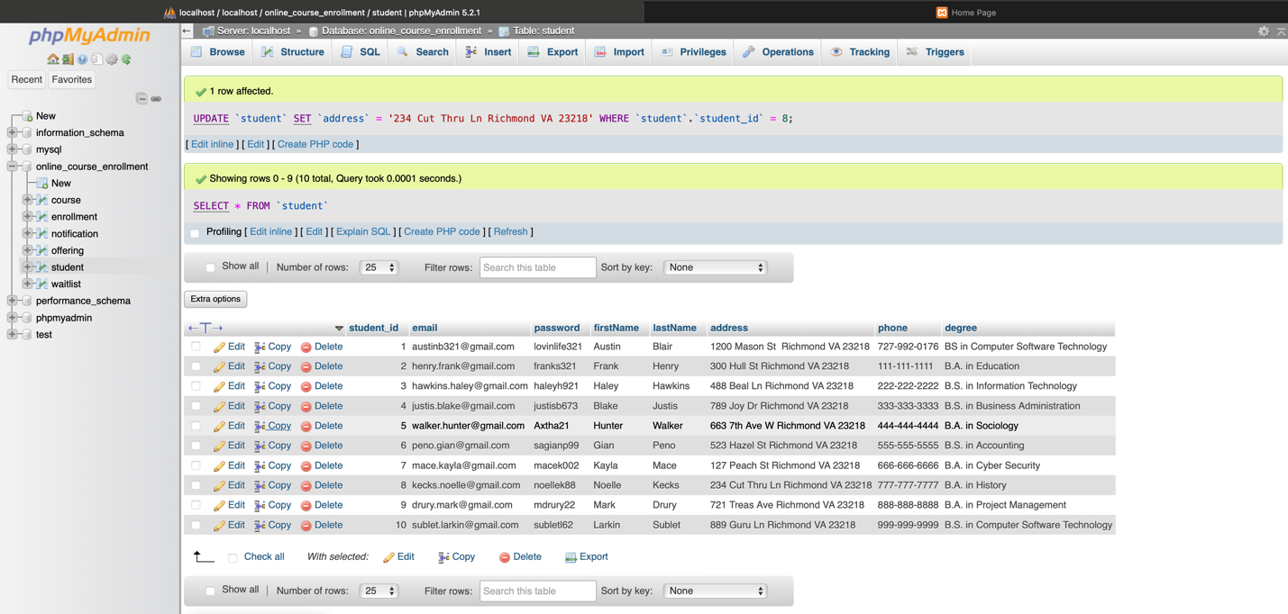

Student Table Before & After

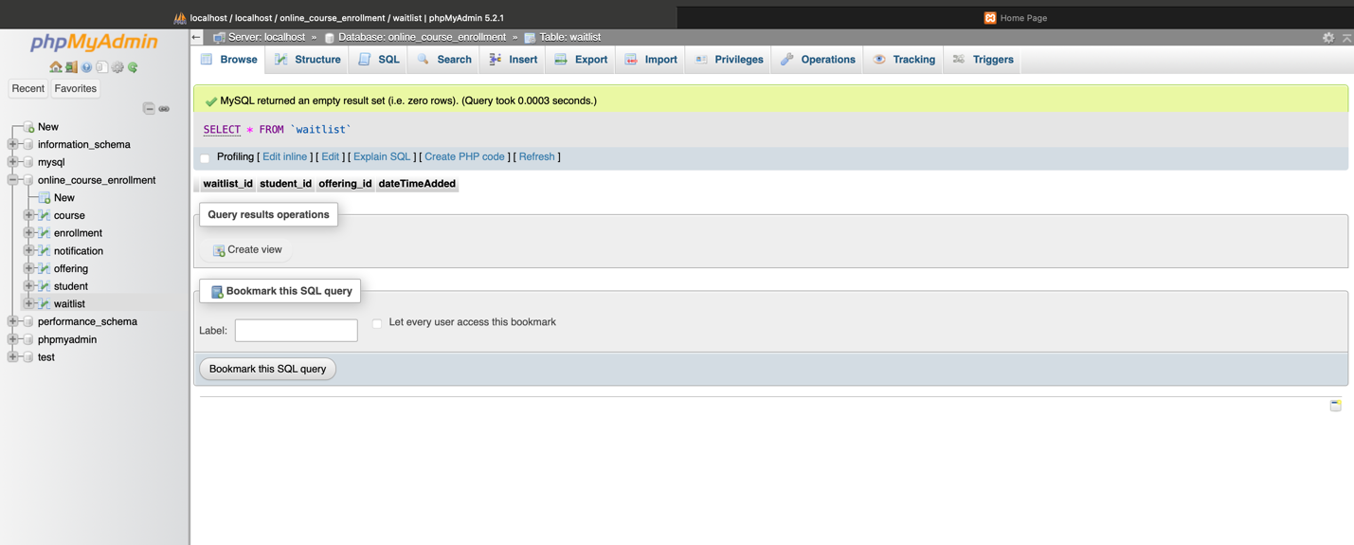

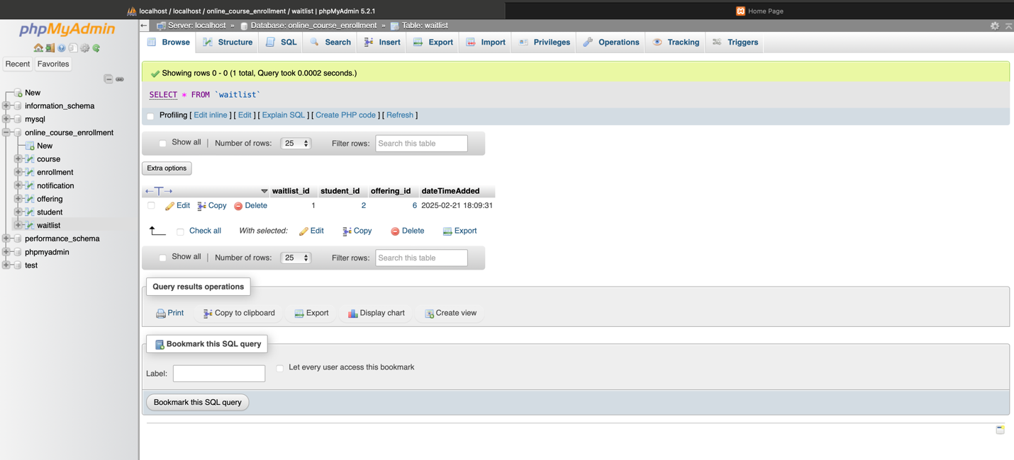

Waitlist Table Before & After

**Website Display**

Home



Login



Registration

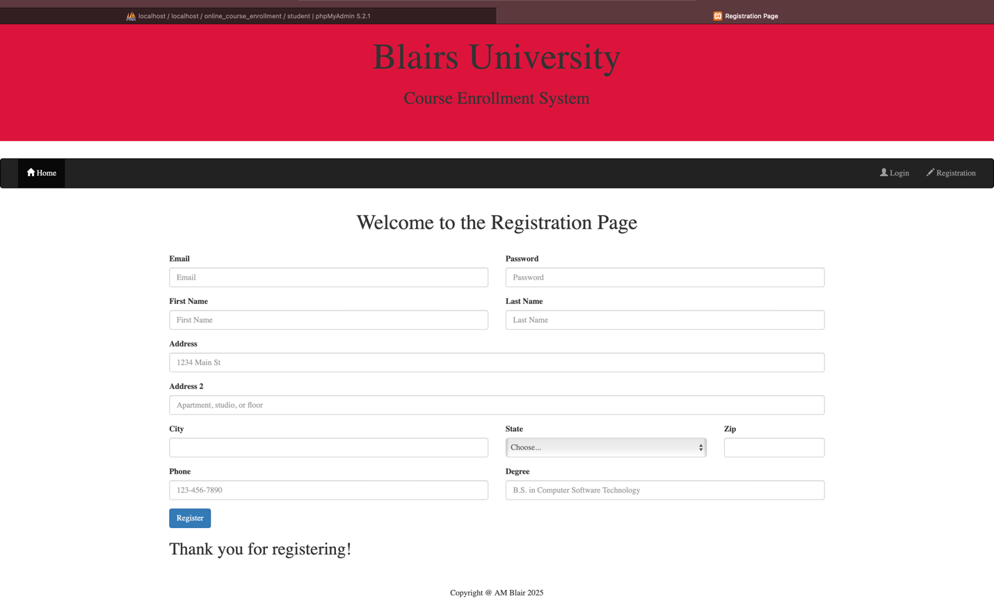

Profile

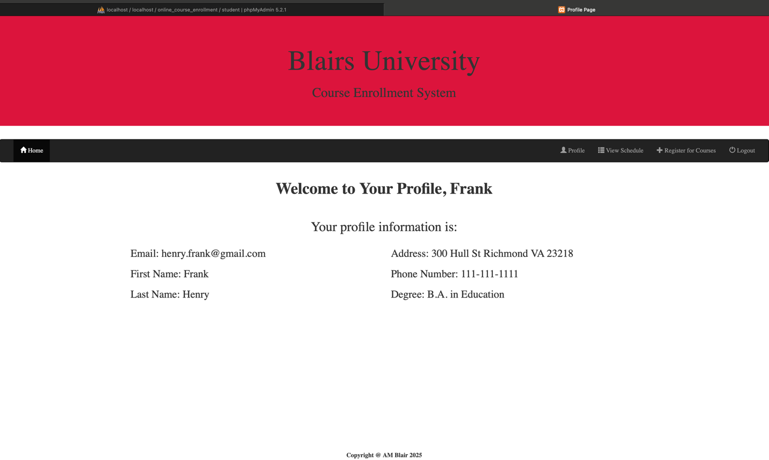

View Schedule

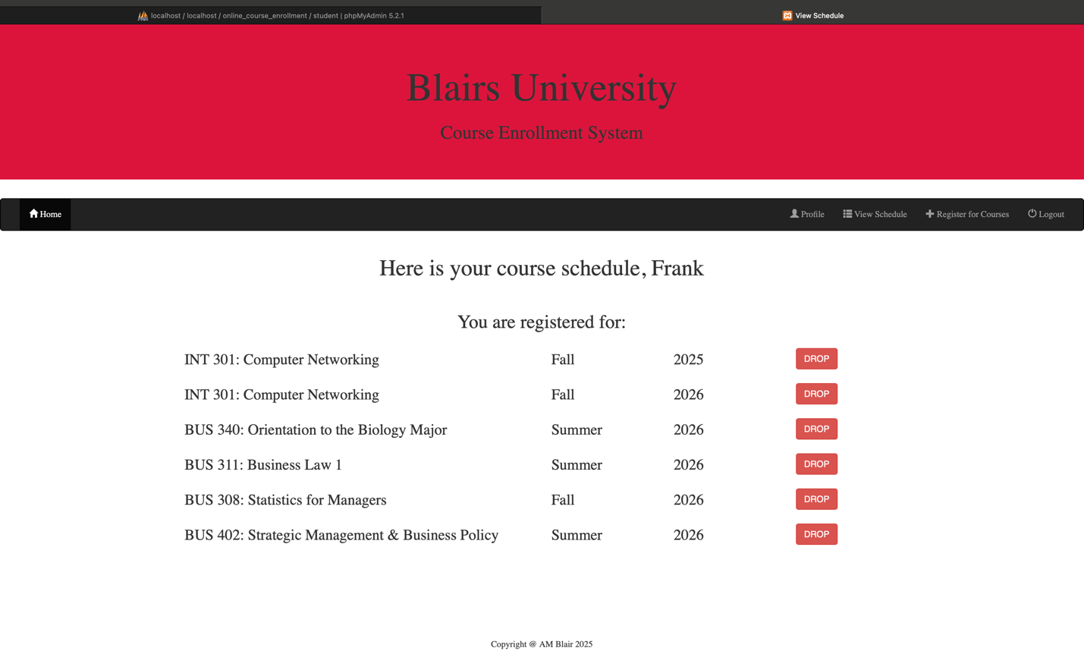



Course Search





**PHP Code**

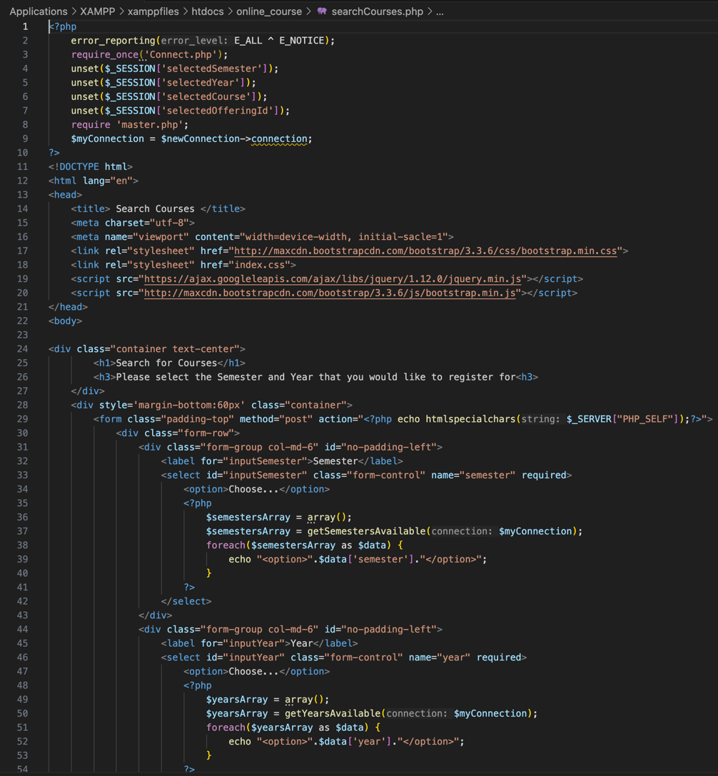

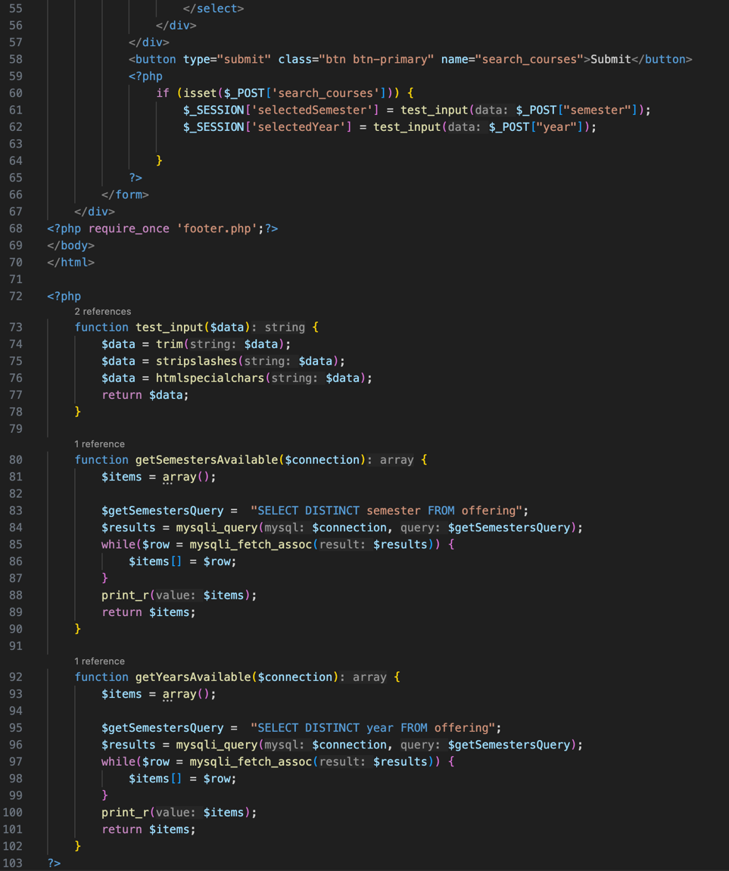

searchCourses.php

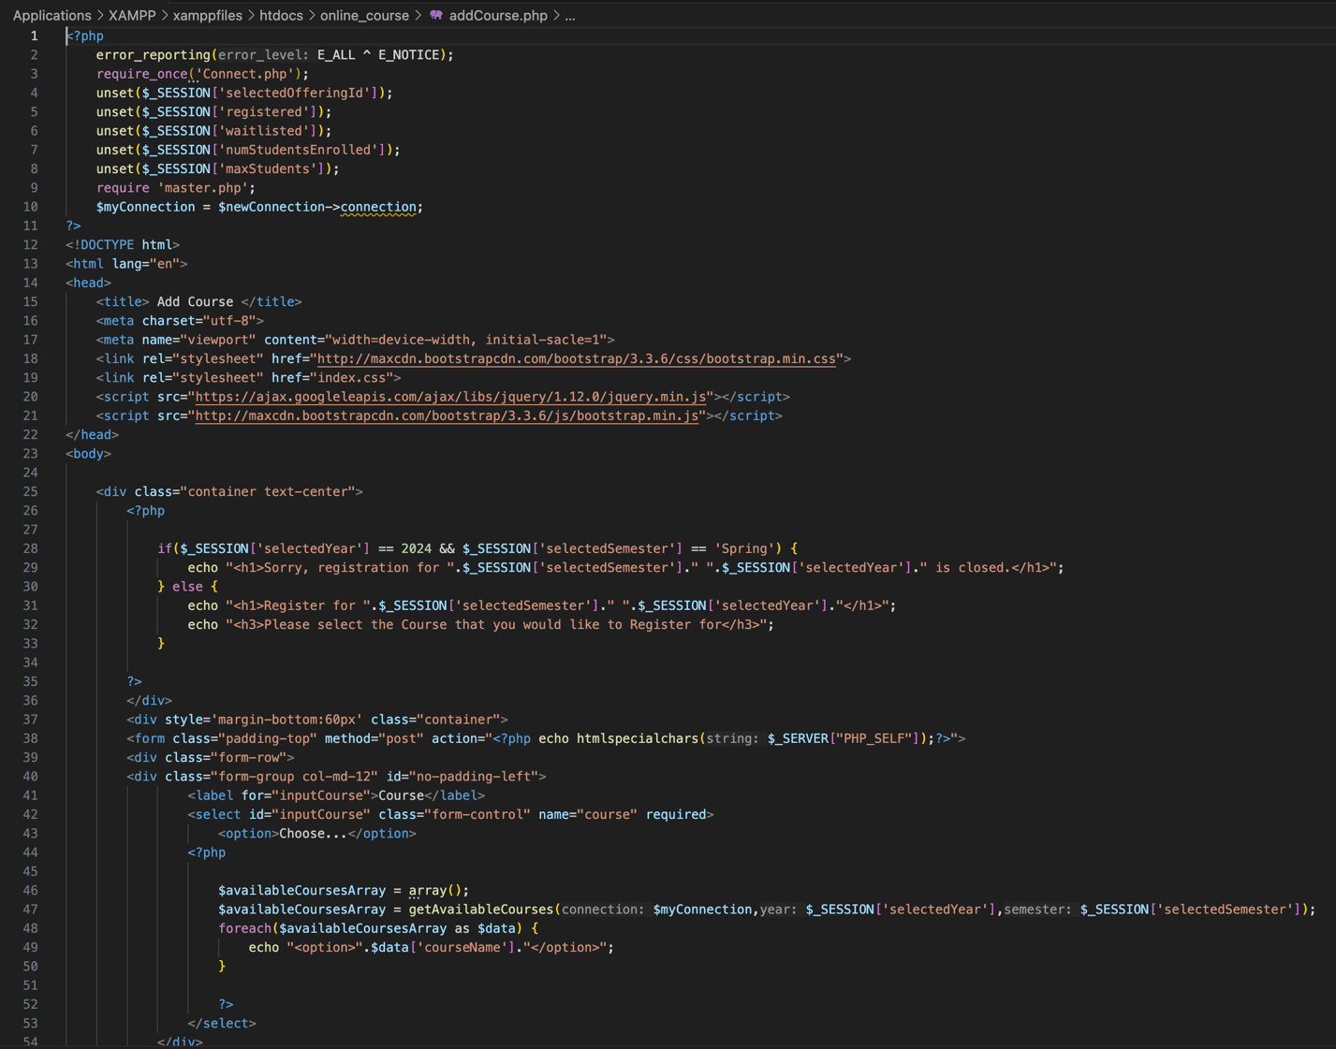

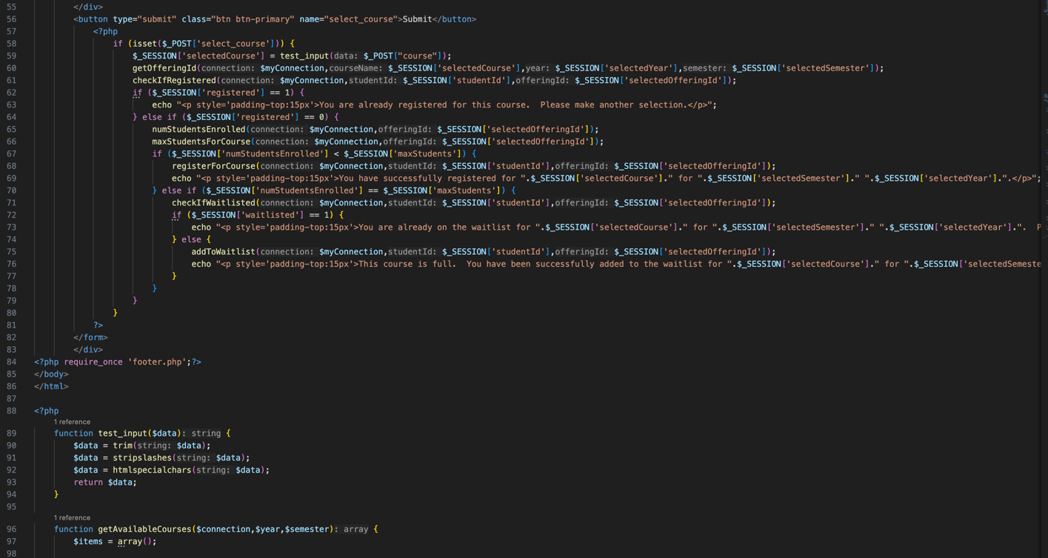

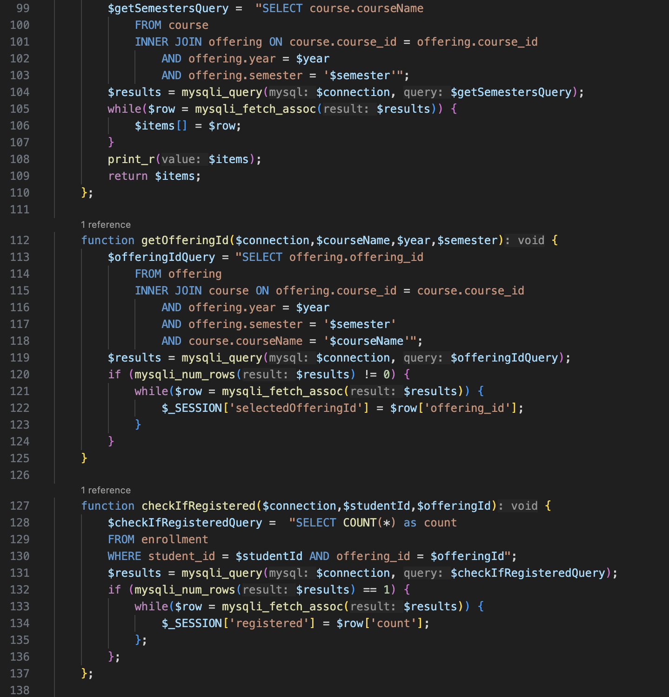

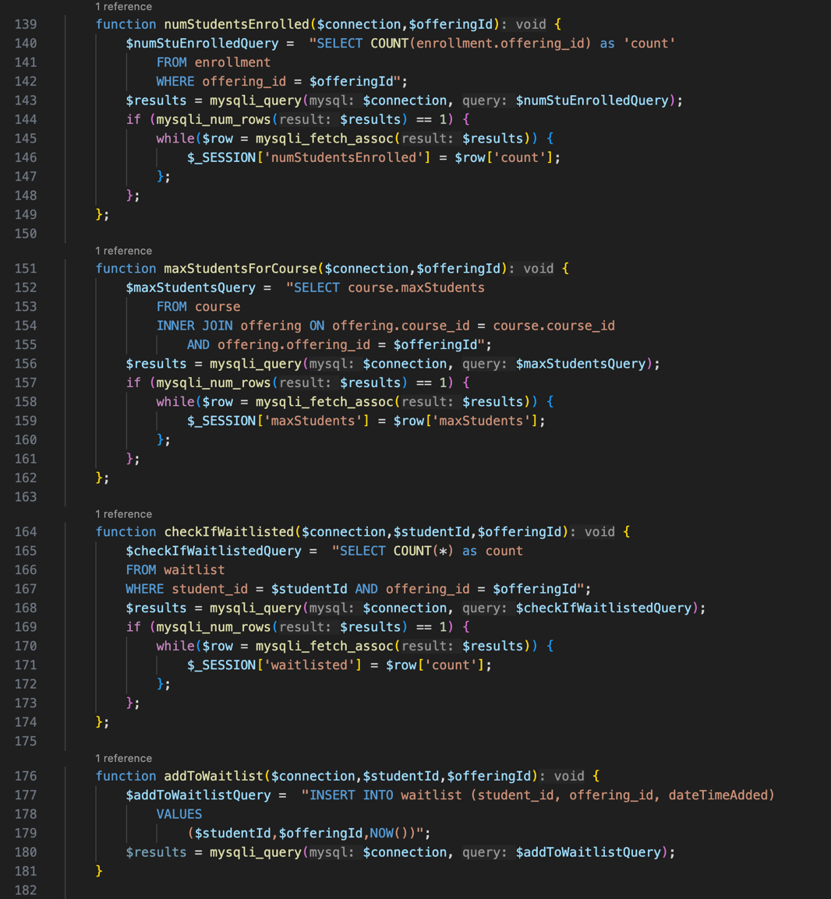

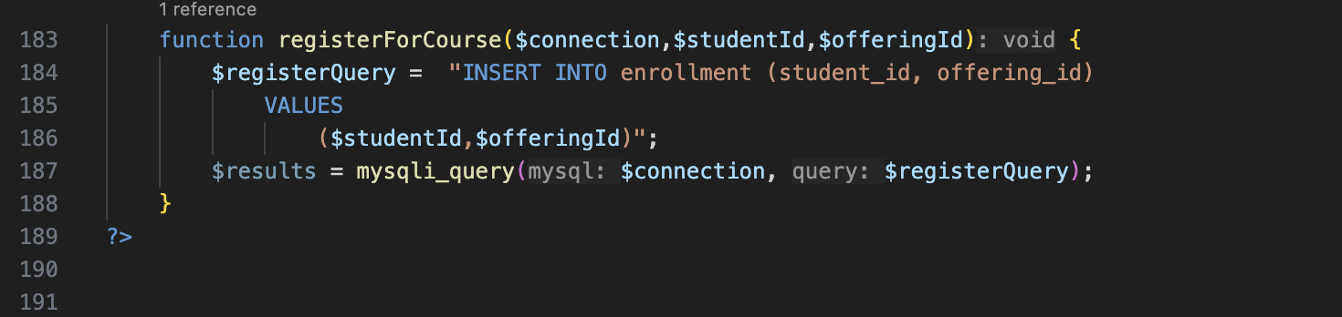

addCourse.php

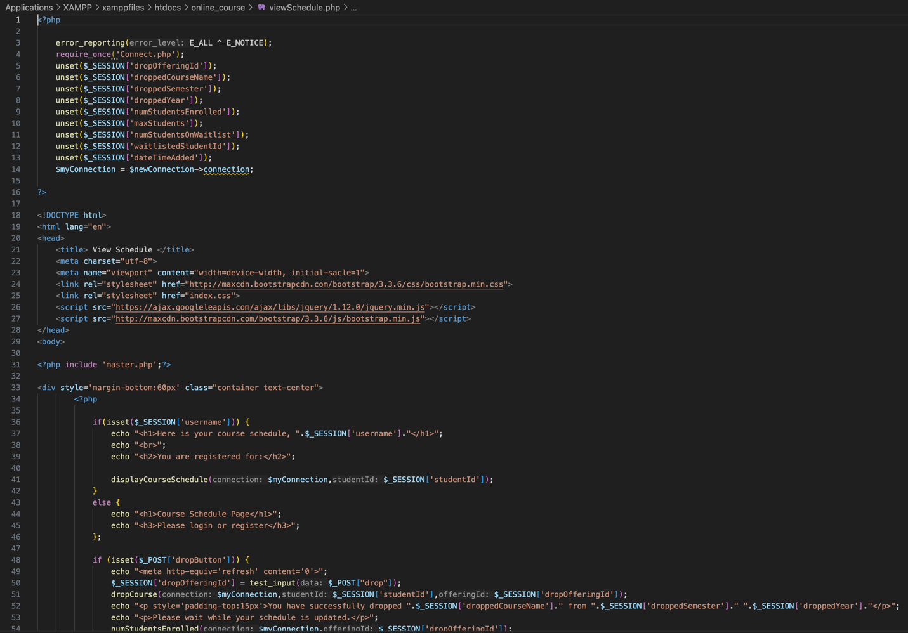

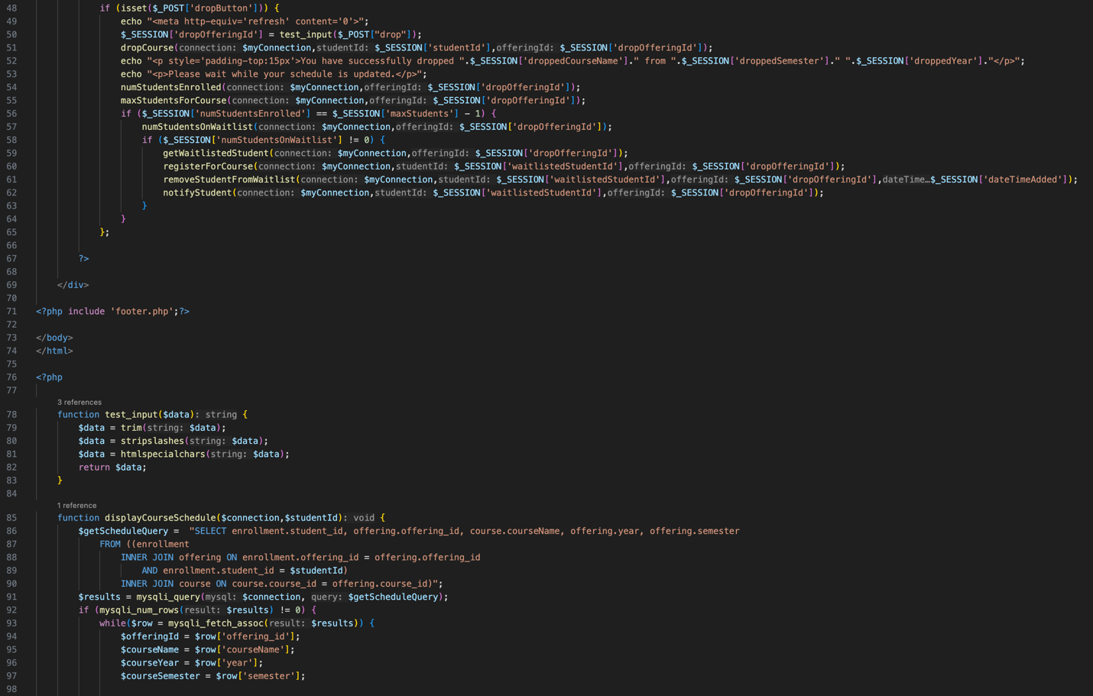

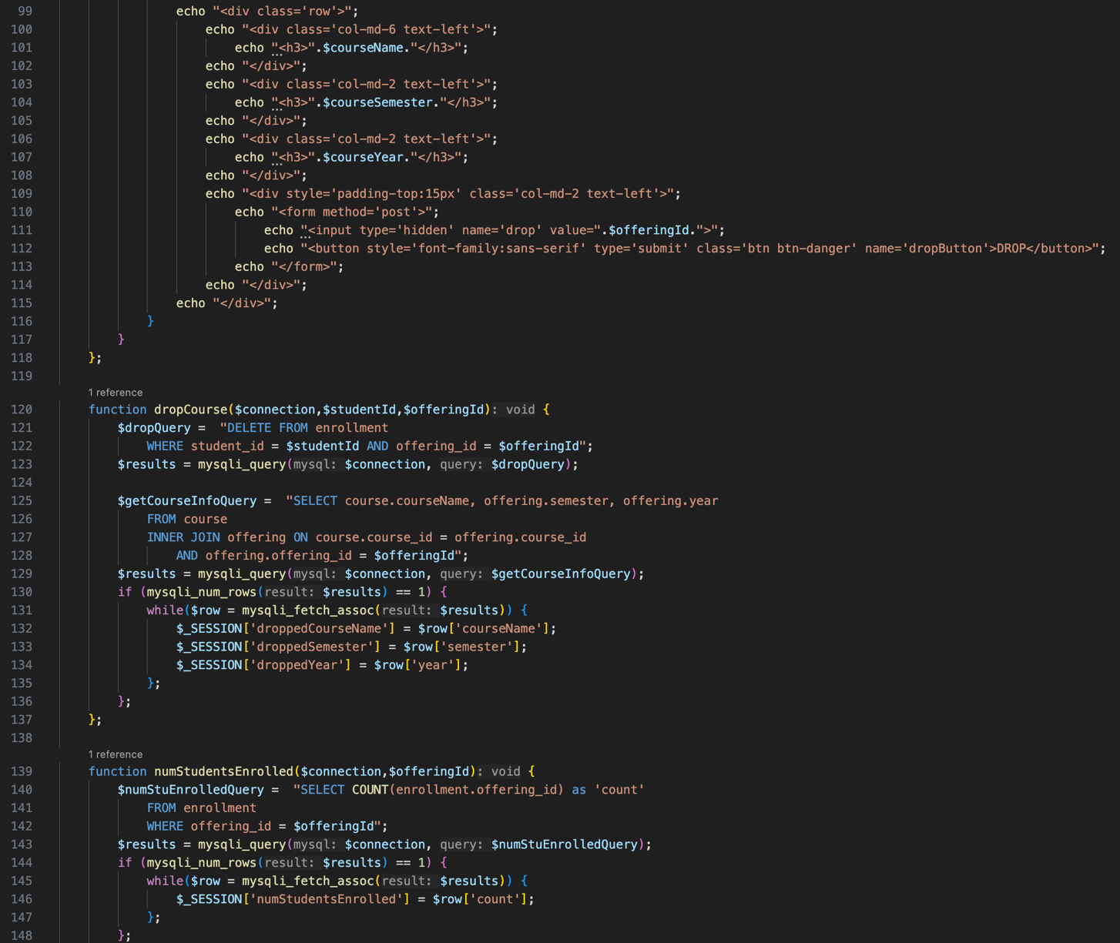

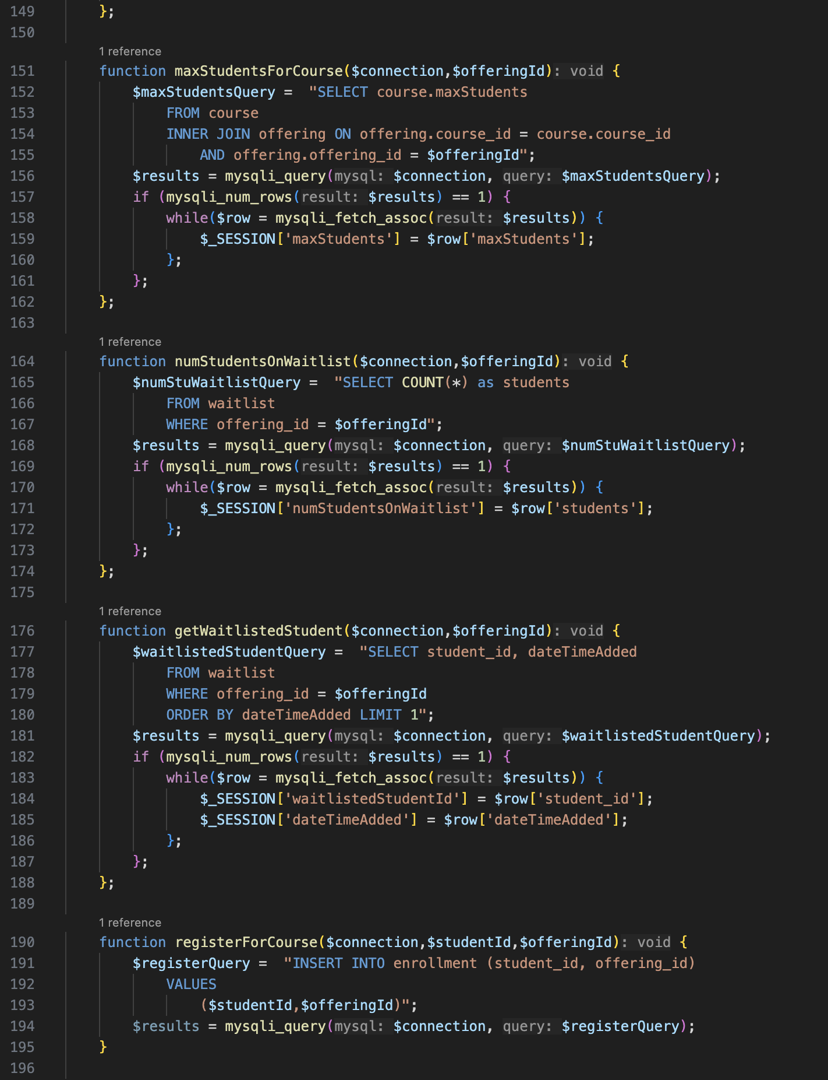

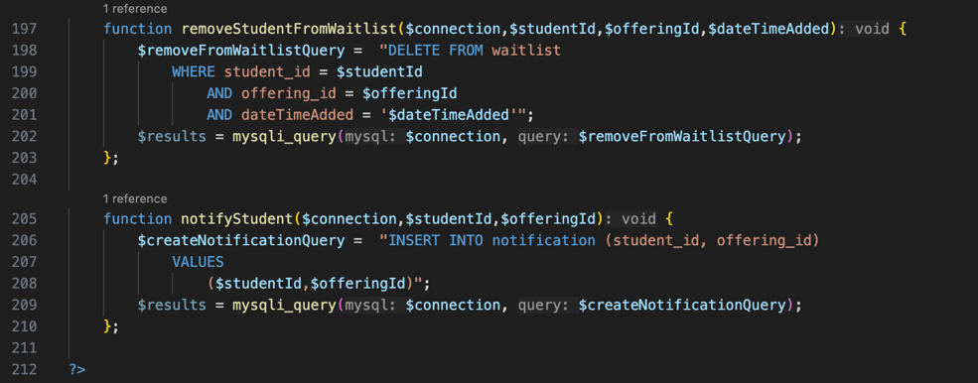

viewSchedule.php

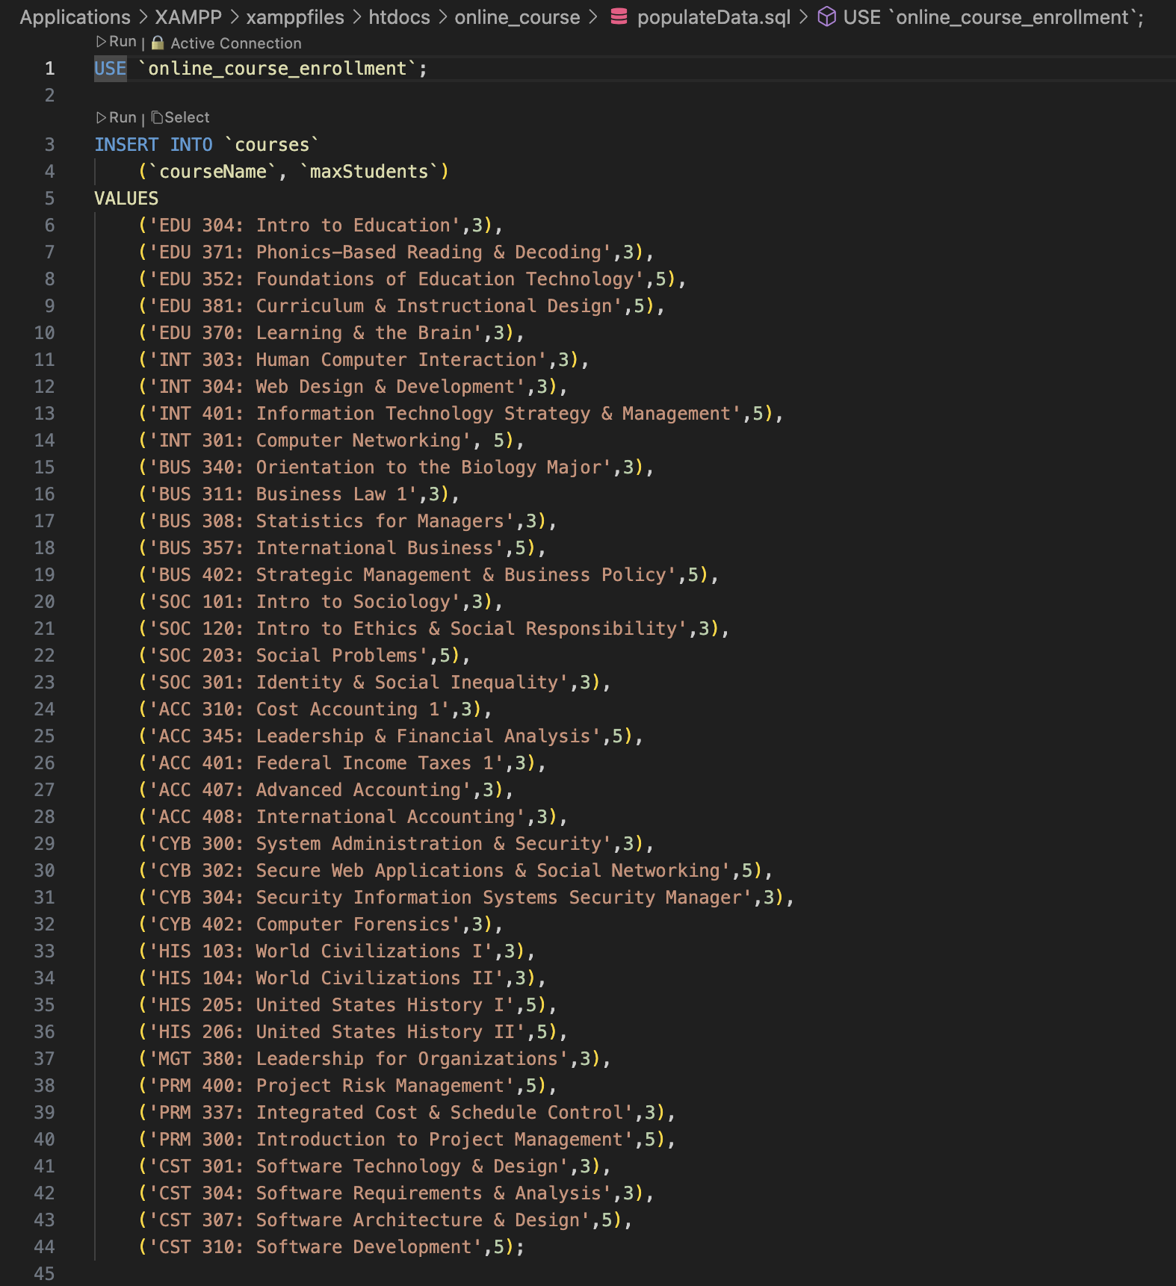

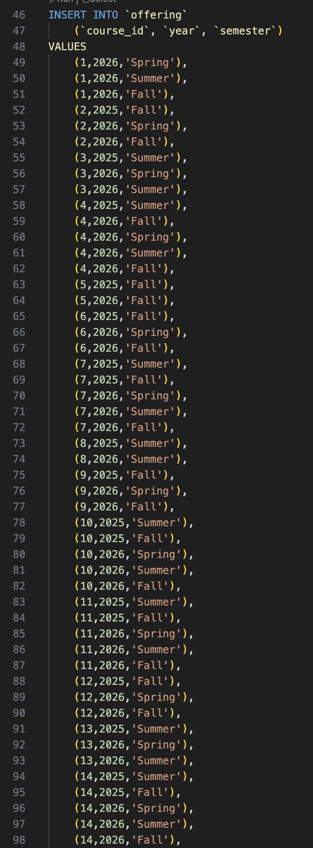

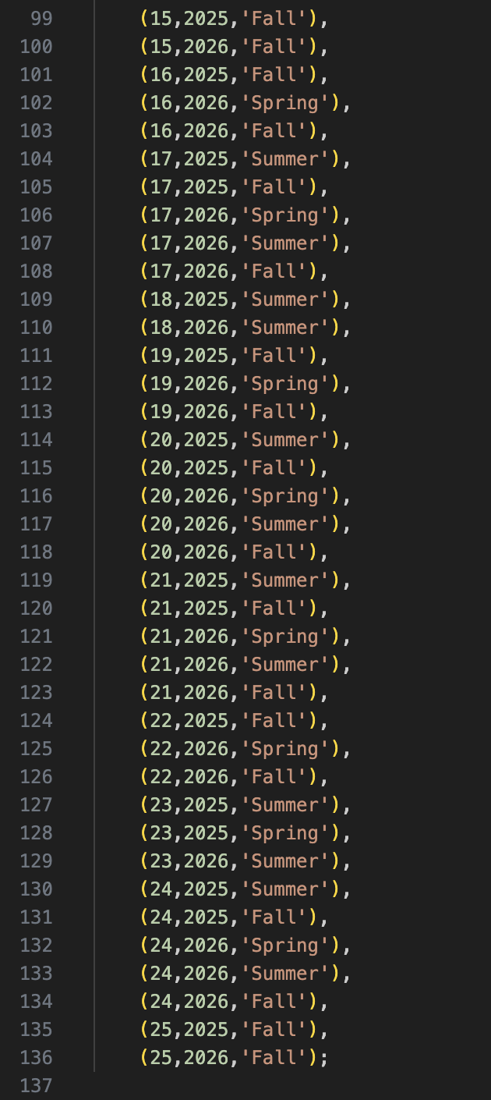

populateData.sql

**Explanation**

For this portion of the Online Student Enrollment Website, I first began by sprucing the home page/master page of my website up a little bit from the first iteration. I was simple, due to time constraints, but I changed the name and color schemes a bit. I also changed the display of the forms for inserting data into the login and registration pages. This made the website look more uniform, and a little more professional. In addition to these changes, I had to alter the navigation bar for when a user has logged in. I utilized the same code structure as with the master navigation bar display, but once a user is logged in, they will be presented with the options **Profile: to view profile | View Schedule: to view registered classes | Register for Courses: to be transfer to the search and register for courses page** and **Logout: to be transferred back to the home page**. I wish there was more time to tweak this overall display of the website, but in the compressed time of the class it is challenging to do so.

To allow users to register for courses, I had to develop a few more tables than in the first iteration of this website. Those included course, enrollment, notification, waitlist, and offering. In addition to that, I created the populateData.sql file to upload courses and when they are offered.

Once the tables and data were inserted into the tables, I had to put the logic together to create the different php source code files to develop the connection between the website and the backend/database. To do so, I created the viewSchedule.php, addCourse.php, and searchCourses.php. I used these nomenclature so it would be easy to know which file did exactly what. The searchCourses.php file allows users, once logged in, to search for available courses per semester and year. The addCourse.php file allows users to add a class to their course schedule, or if full, be added to the waiting list. The viewSchedule.php file allows users to view which classes they are registered for, and if changes need to be made, they can drop course(s).

**Challenges**

During this implementation process I honestly had to do quite a bit of research to determine the best method for connecting the website to the backend/database for course registration. This included many YouTube videos and additional research on Stack Overflow and GitHub. As I have come to realize, as with many of my friends who work as developers, you will not always have the answers. Research is an important aspect of being a developer and knowing how to use your resources to overcome challenges and find solutions to problems. As I mentioned before, due to time constraints I was unable to make the website look as professional as I would like. With that said, I believe the purpose of this assignment was to achieve functionality not aesthetics. This assignment has been challenging but also rewarding.